BOOKENDS HOSPITALITY PVT. LTD.
Internal Operations — Regulatory Readiness Series

FSSAI Schedule 4 & FDCA Compliance Readiness Report

CAPICHE — Ambli, Ahmedabad, Gujarat

Outlet / Brand | Capiche
Location | Ambli, Ahmedabad, Gujarat
Business Category (presumed) | Restaurant
Report Type | Internal walk through dated 15 August 2026.
Inspection/Audit By | Vishal Patel
Report Prepared By | Vishal Patel

Ref | Priority | What the evidence shows
K19 ★ | Critical | A pest (cockroach) was photographed on the floor on the audit day, despite this checkpoint being scored 2. The pest-control certificate on file is addressed to a different business name and had already lapsed for over a  year.
K15 ★ | 1 evidence | Fitness certificates not available.

Ref | Checkpoint | Rating | Priority | Remark
S1 ★ | FSSAI licence displayed and valid; Food Safety Display Board put up | 4 | Compliant
Ref | Checkpoint | Rating | Priority | Remark
S2 | FSSAI licence number printed on menu | Non-Compliant | High | 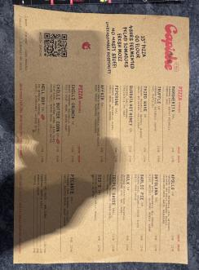  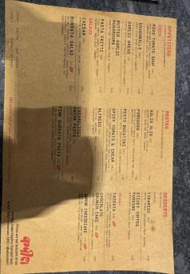

Ref | Checkpoint | Rating | Priority | Remark
S8 | Hand wash or sanitizer available for guests and staff | 2 | Compliant | —
S10 | Drinking water potable/filtered; dispenser and jug clean | 1 | Partial | 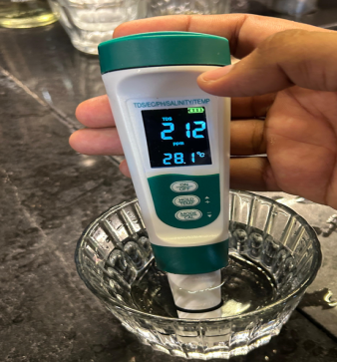
S13 | Restrooms clean and stocked; doors do not open directly into food area | 0 | Major | 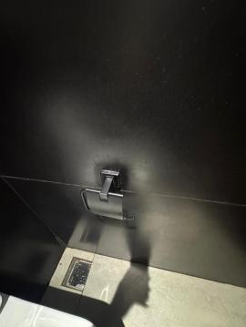
K18 | Hand wash stations stocked — soap, sanitizer, paper towel | 2 | Compliant | —
K20 | Drain traps in place, flowing and clean; no standing water | 2 | Compliant

Ref | Checkpoint | Rating | Priority | Remark
S11 | Table condiments/sachets within expiry date; containers clean | 2 | Compliant
K1 ★ | No expired or undated items anywhere on the premises | 0 | Major | 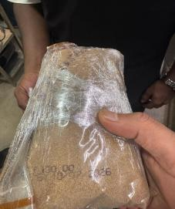  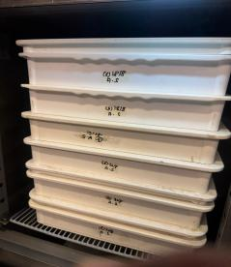  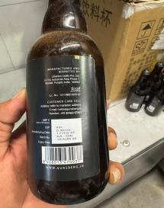
Ref | Checkpoint | Rating | Priority | Remark
K2 | Decanted containers labelled with name and date; FIFO followed | 0 | Major | 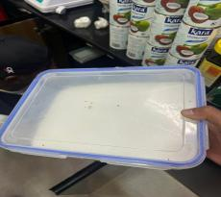  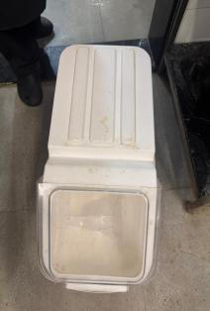  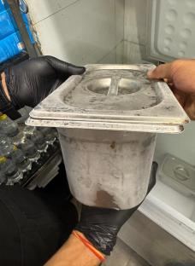

Ref | Checkpoint | Rating | Priority | Remark
K4 ★ | Raw and cooked food completely segregated | 4 | Compliant | —
K5 ★ | Veg segregated in storage and prep | 4 | Compliant | —
K6 ★ | Chiller ≤ 5°C, freezer − 18°C; temperature log up to date | 4 | Compliant | —
K7 | Hot holding ≥ 60°C; cooking to a core temperature ≥ 75°C | 2 | Compliant | —
K8 | Thawing only under refrigeration — never at room temperature | 2 | Compliant | —
K12 | Frying oil within TPC limit; oil-change log up to date | 2 | Compliant
K14 | Only approved colours/additives used; declaration on file | 2 | Compliant

S3 | Tables, chairs and other guest-area surfaces clean and sanitized | 0 | Major |  | 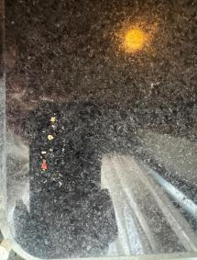
S12 | Waste bin covered, foot-operated, not overflowing | 2 | Compliant
S14 | Pest barrier functional at entrance (air curtain / insect-o-cutor); no signs of pests in dining area | 0 | Major | No record
K9 | Chemicals labelled not mention and stored away from food | 0 | Major | 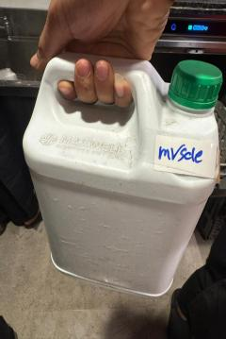  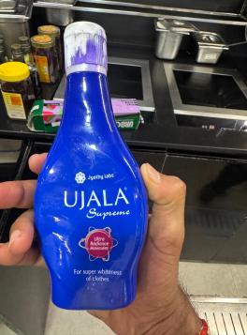
K19  ★ | No pest activity; pest-control service record up to date; stations mapped | 0 | Major | No record
K21 | Waste segregated, bins covered, emptied daily | 2 | Compliant

Ref | Checkpoint | Rating | Priority | Remark
S6 | Service staff in clean uniform  — cap, trimmed nails, no jewellery | 0 | Major | 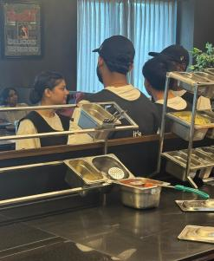
S7 | No unwell staff on duty; cuts/wounds covered with waterproof dressing | 2 | Compliant
K15 ★ | Medical fitness certificate up to date for every food handler | 0 | Major | Not available
Ref | Checkpoint | Rating | Priority | Remark
K17 | Kitchen staff — cap, apron, trimmed nails, no jewellery; no smoking or paan | 0 | Major | 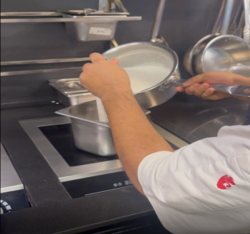  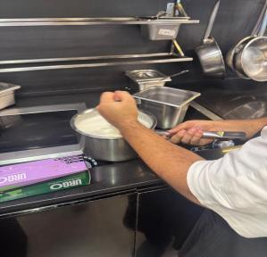
K3 | Storage 15 cm off the floor; no cartons or food on the floor. | 2 | Compliant | —
K10 | Dry store clean, ventilated, pest-free. | 2 | Compliant | —
K11 | Colour-coded boards / separate prep tools in use | 2 | Compliant | —
K13 | Food-contact surfaces and equipment clean — no rust, damage or wooden patches | 2 | Compliant | —
K22 | Exhaust and hoods degreased; ventilation adequate; lights protected | 2 | Compliant | —

Ref | Checkpoint | Rating | Priority | Remark
S15 | Veg mark and allergen information on menu, where applicable | 0 | Major | 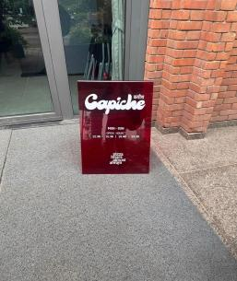
Ref | Checkpoint | Rating | Priority | Remark
K16 | FoSTaC-certified supervisor on roster; certificate available | 0 | Major | Not available
Ref | Checkpoint | Rating | Priority | Remark
K23 ★ | Water potability report valid  — tested within the last 6 months | 0 | Major | Team reports an informal daily check is done, but there is no documented report; the formal 6-monthly lab report has not been renewed. & TDS-1457.
K24 | Deep-cleaning schedule up to date and followed; dispense log with temperature (CK checklist) | 0 | Major | 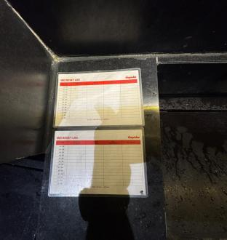
S4 | Floors, walls, ceiling clean — no cobwebs, seepage or flaking paint | 1 | Partial | 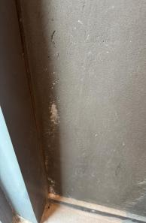  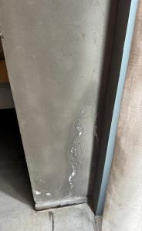  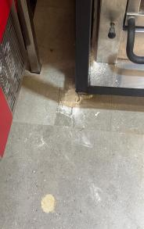
S5 | Counters and display units clean; displayed food covered and temperature-held. | 2 | Compliant | —
S9 | Crockery, cutlery and glassware clean, chip-free, stored covered. | 0 | Major | 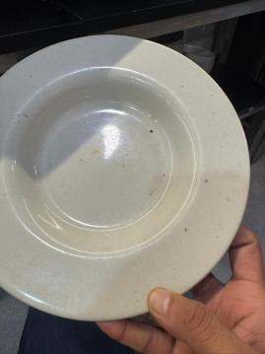

Score & Grade
Section | Available marks | Obtained marks | %
A — Service Area | 32 | 16 | 50.0%
B — Kitchen Area | 62 | 36 | 58.1%
Total (Overall) | 94 | 52 | 55.3%

Conclusion
- Overall standing — 52/94 (55.3%), Needs Improvement; all 39 checkpoints were scored. 4 of the 8 ★ criticals are Non-Compliant (K1, K15, K19, K23), but S1 passes — the licence is displayed and valid — and K4, K5 and K6 hold, so segregation and the chiller and freezer controls are sound.
- The service area has slipped to the 50% floor — 16/32 (50.0%) exactly, against the kitchen's 36/62 (58.1%). Seven of the fifteen service checkpoints now fail, and every one is visible to a guest: guest-area surfaces (S3), staff uniform and grooming (S6), chipped or unclean crockery (S9), restrooms (S13), the entrance pest barrier (S14), and both menu items (S2, S15). A single further downgrade takes this section into the Non-Compliance band.
- Route to Satisfactory — the four documentation items (K15, K16, K23, K24) carry 12 marks, lifting the outlet to 64/94 (68.1%); clearing the pest pair (S14, K19) as well reaches 70/94 (74.5%). Passing the 80% band needs at least 8 checkpoints closed, including all four failing criticals.

